**NATIVES – Native to California, perennial grasses plus two legumes**

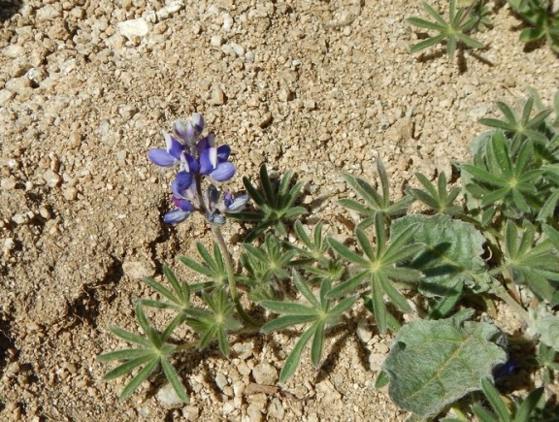 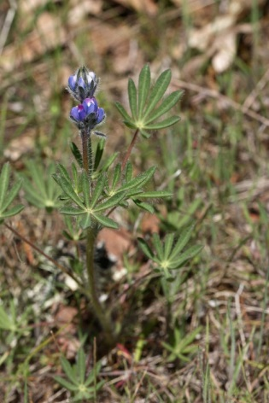

Miniature lupine, *Lupinus bicolor*

Small plant, palmate leaves, purple and white flowers in spring

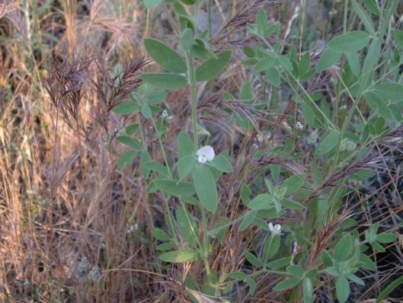 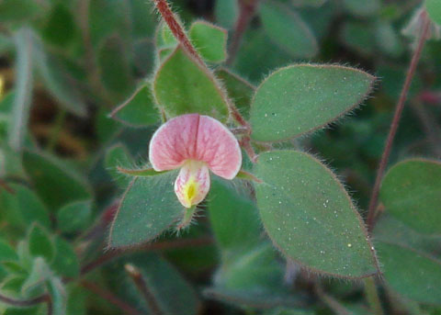

Bird’s-foot trefoil, *Lotus purshianus* (“Lotus”)

Three leaflets in compound, pinkish pea-like flowers. Small in spring, then grows and flowers over summer

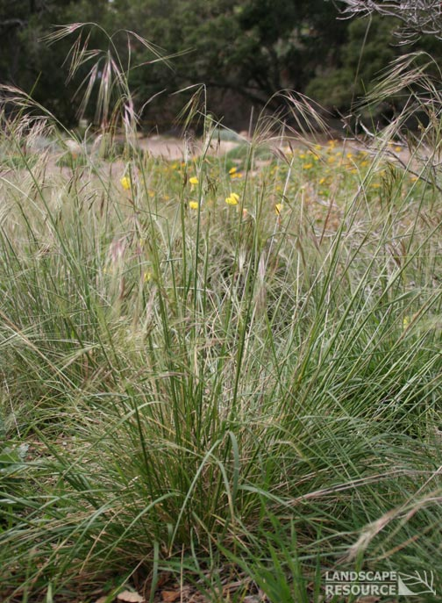 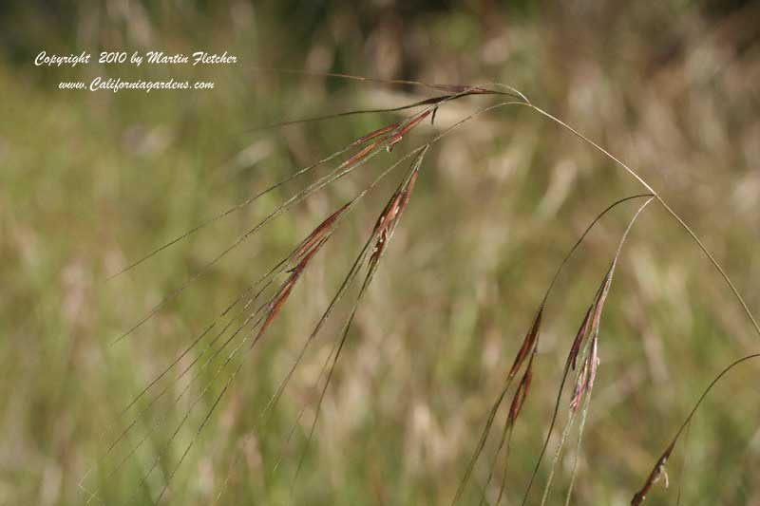

Purple needlegrass, *Nassella pulchra* (now *Stipa pulchra*)

Perennial bunchgrass, thin & smooth purple seeds. Florescence looks similar to *Bromus diandrus*, but seeds are smooth, and usually grows in dense bunch.

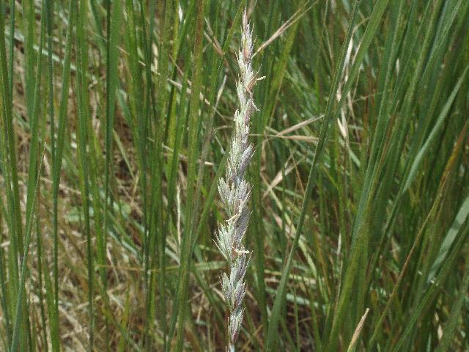 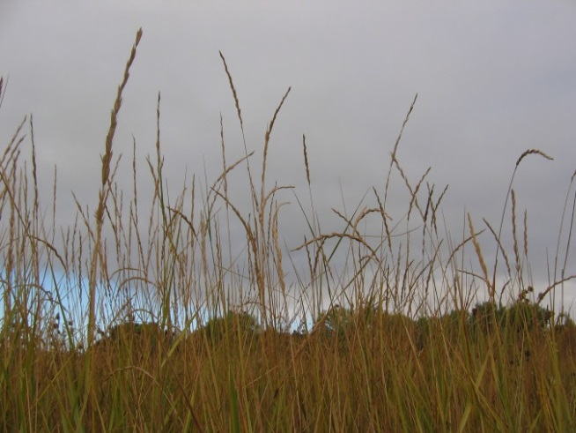

Alkali wild rye, *Leymus triticoides* (now *Elymus triticoides*)

Perennial grass, grows in bunch or tillers

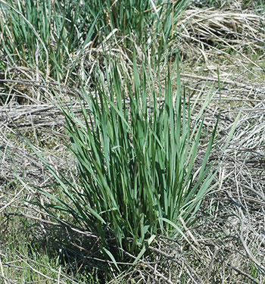 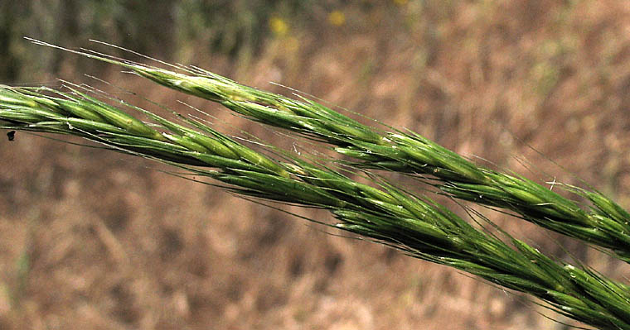

Blue wild rye, *Elymus glaucus*

Looks like *E. triticoides,* but with longer awns on seeds

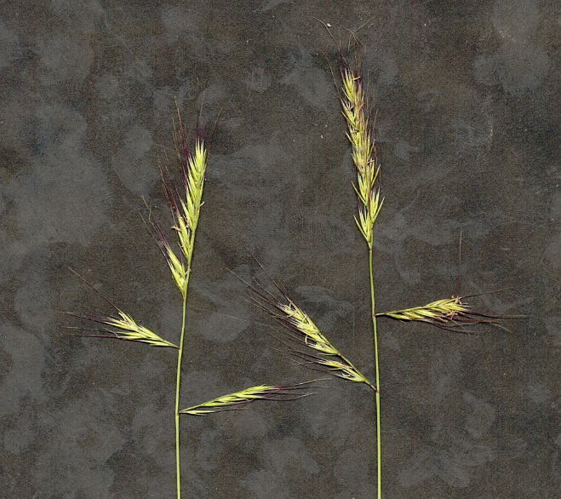 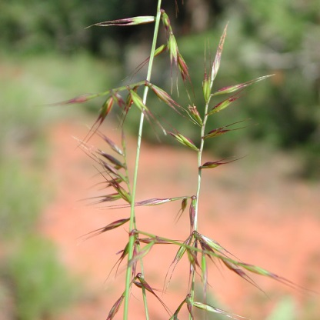

Small Fescue, *Vulpia microstachys*, now *Festuca microstachys*

Native annual grass, did not establish well at site – unlikely to find it.

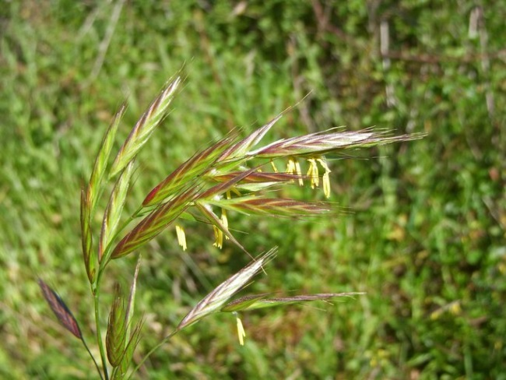 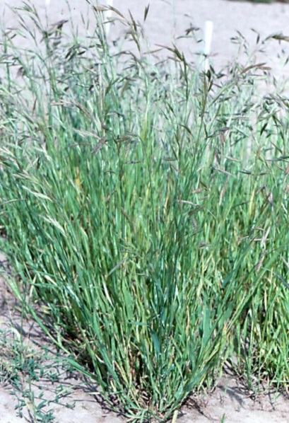

California brome, *Bromus carinatus*

Perennial grass, present but uncommon at site. Very difficult to distinguish from *Bromus hordeaceus* – requires close inspection of flowers.

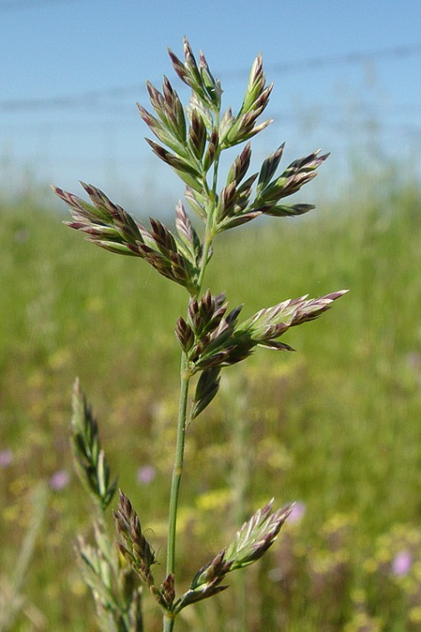 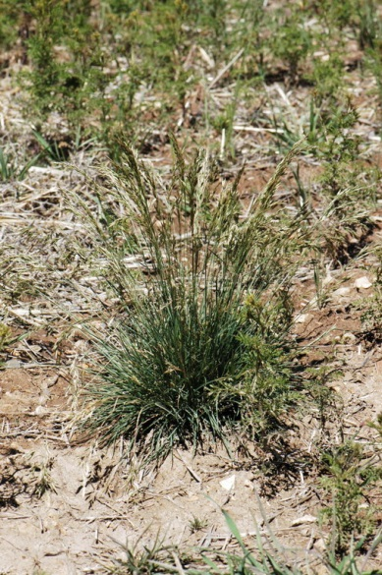

Bluegrass, *Poa secunda*

Did not establish well at site – unlikely to find it out there.

**ANNUALS (Naturalized non-natives)**

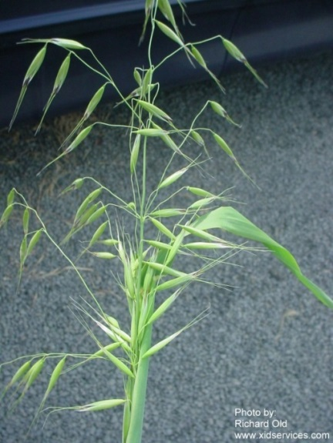 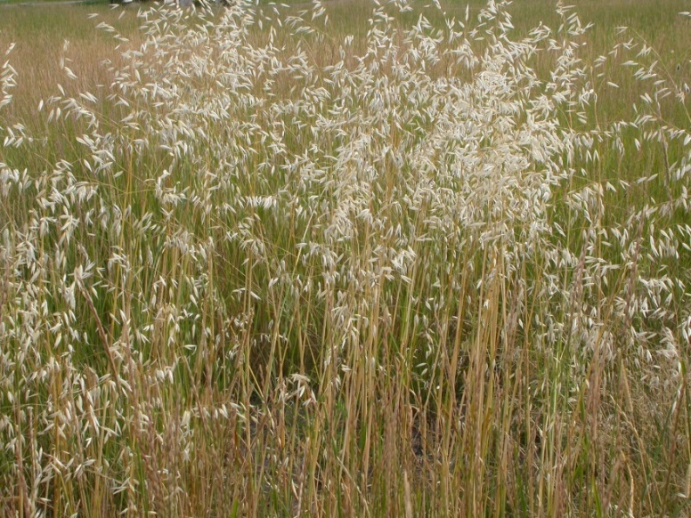

Wild oats, *Avena fatua*

Big annual grass, easily recognized flowers and seeds

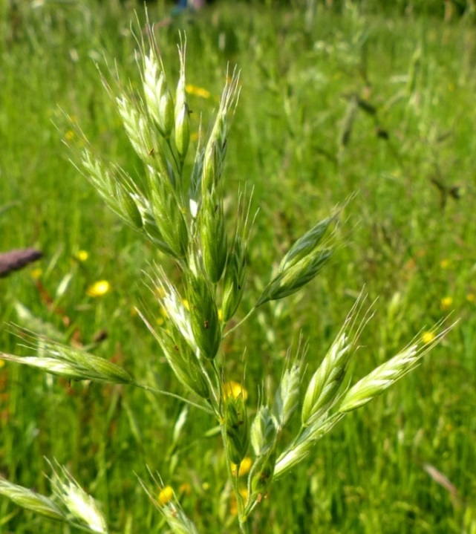 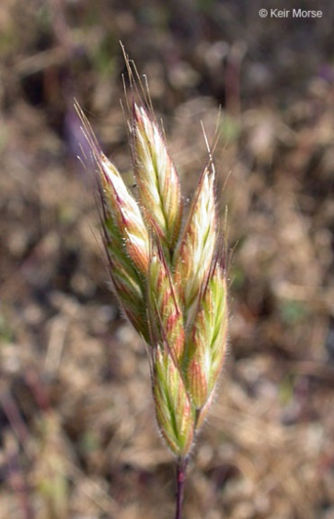

Soft brome / soft cheat / soft chess, *Bromus hordeaceus*

Usually small, stems and flowers feel soft and fuzzy, flowers early

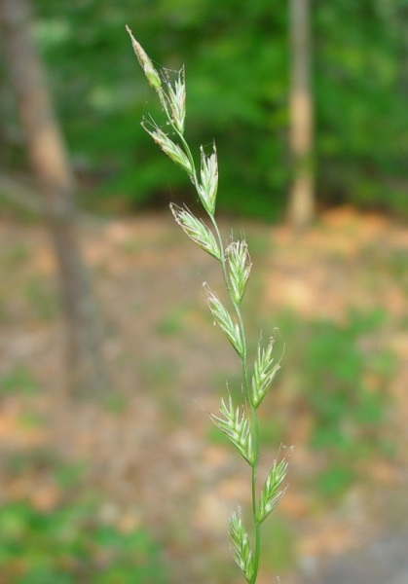 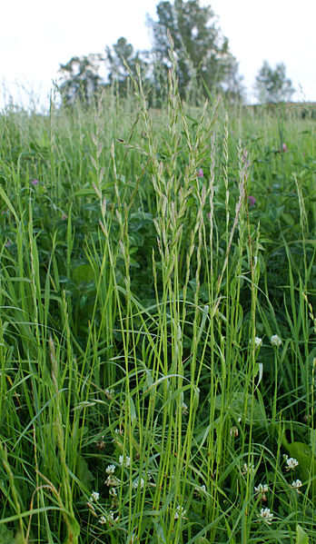

Annual ryegrass, *Lolium multiflorum*

Alternating seedheads along stem

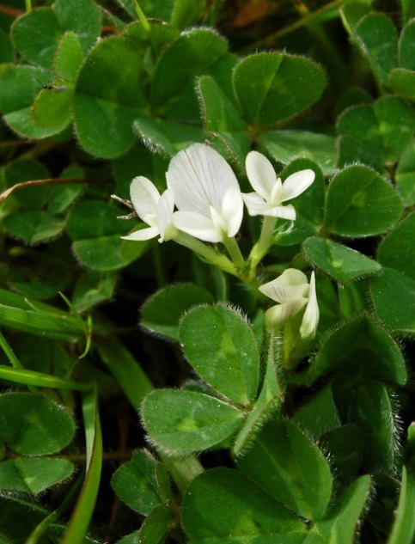 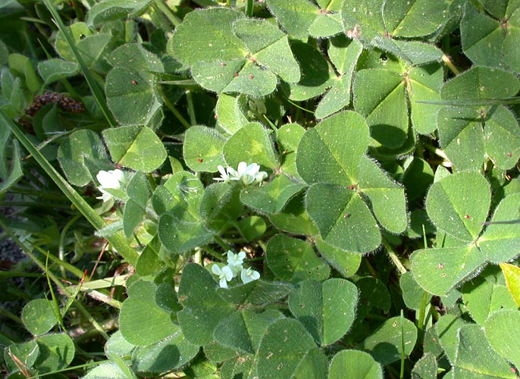

Subterranean clover, *Trifolium subterraneum*

Annual clover (legume). Big three-lobed leaves and white flowers (if you find one with 4 leaves, a pot of gold lies near…)

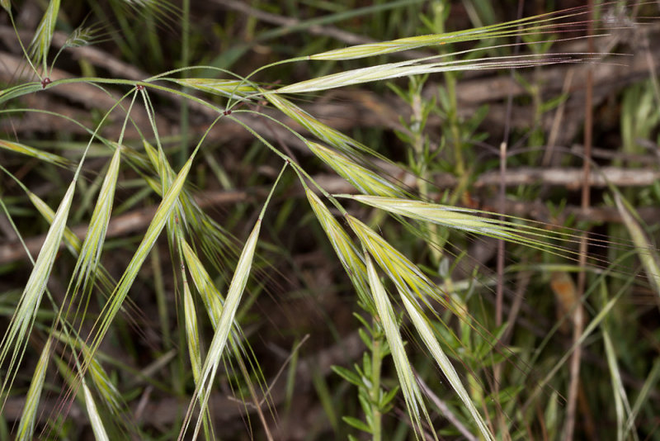 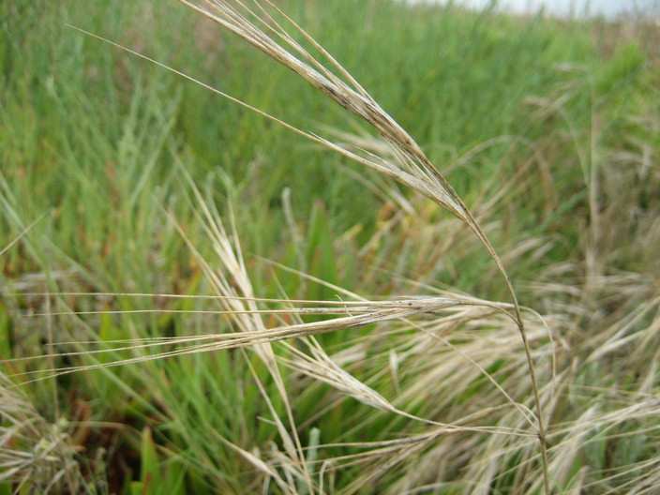

Ripgut brome, *Bromus diandrus*

Was not planted at the site, but part of the annual group. Seeds are very rough when rubbed the wrong way (and get stuck in your socks). Superficially resembles *Nasella pulchra*, but grows from single annual stem, not from dense tussock.

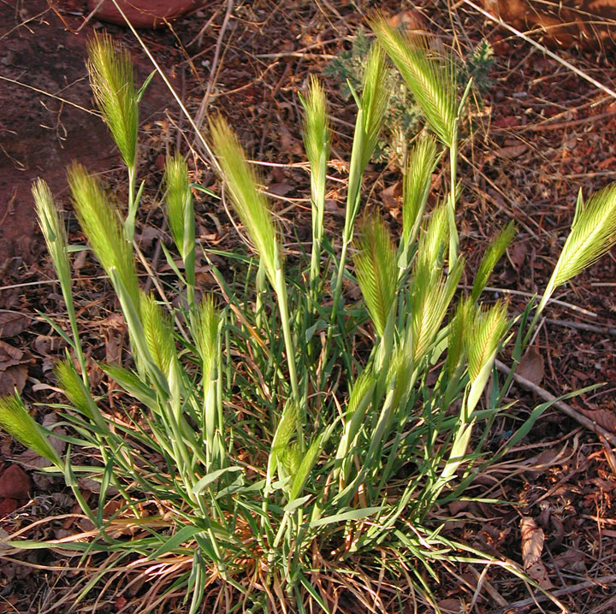 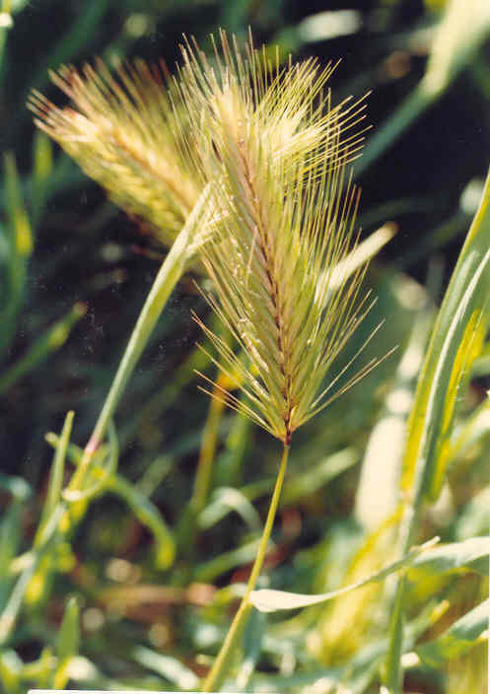

Wild barley, *Hordeum murinum*

Characteristic spiky seedhead. Was not planted at the site, but part of the annual group.

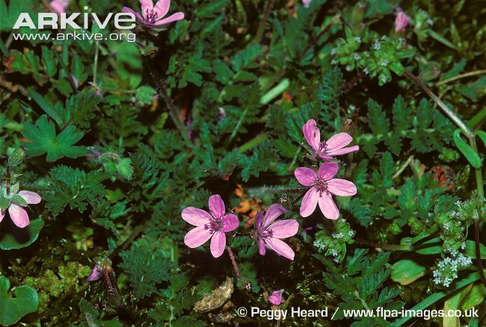 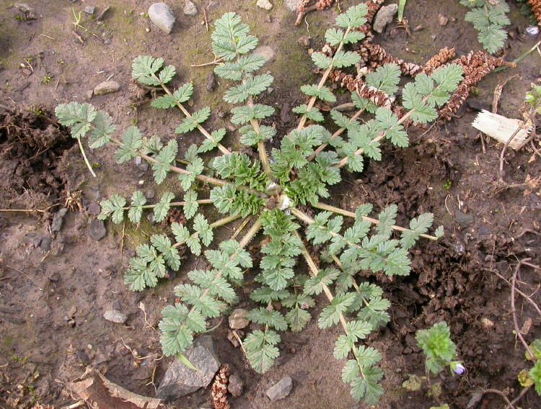

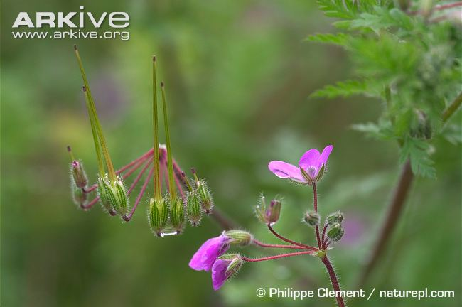 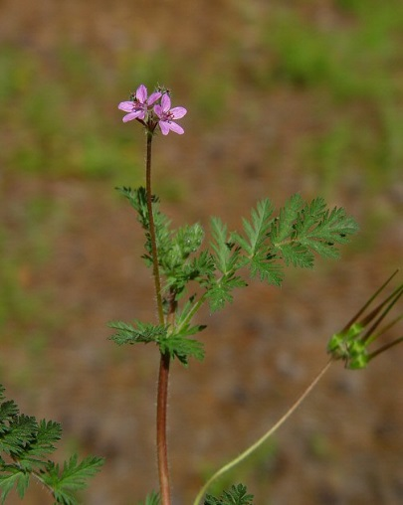

Filarees, *Erodium* (“Erodium,” various species)

Annual forbs. Lobed leaves and radial growth pattern. Purple flowers and green seeds with long “beaks.” Flowers before most grasses. Note: was not planted at the site, but part of annual species mix. Tends to germinate in gopher mounds and other disturbed areas.

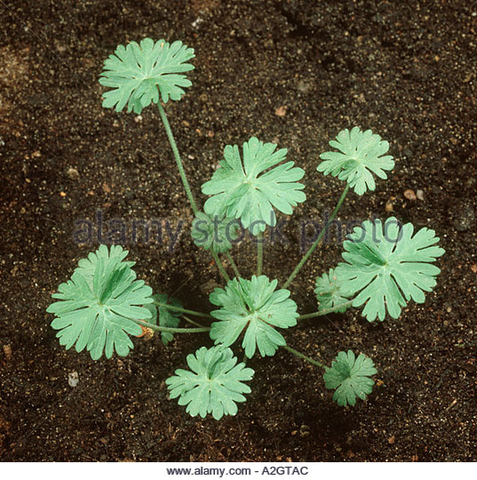 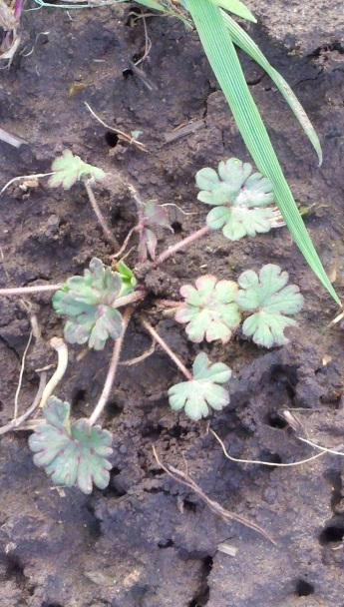 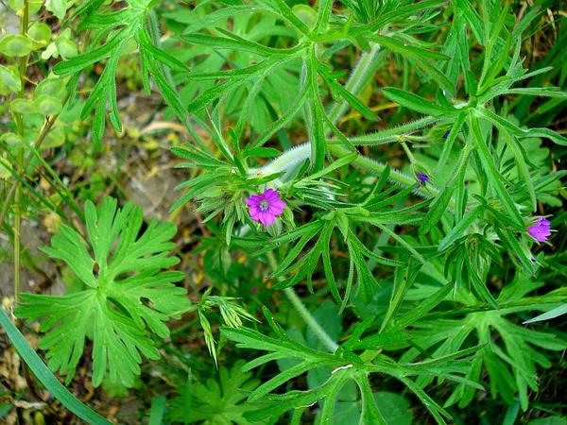

Cutleaf geranium, *Geranium dissectum*

Growth pattern is similar to *Erodium*, but with circular, lobed leaves. Purple flowers, mature plant is very fragrant. Note: was not planted at the site, but part of annual species mix.

**WAPS (Noxious invasives) – Two annual grasses, mature later than ANNUALS**

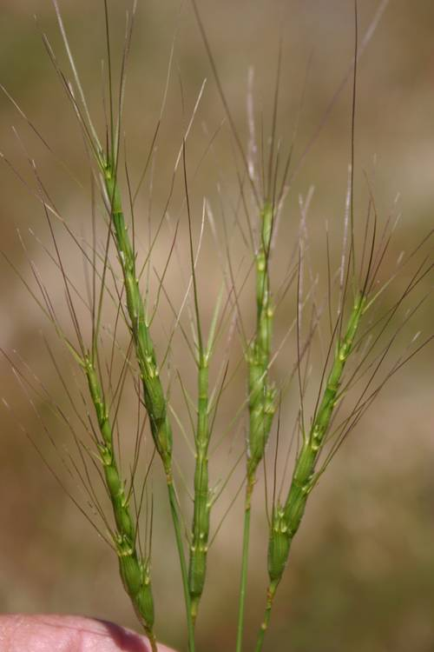 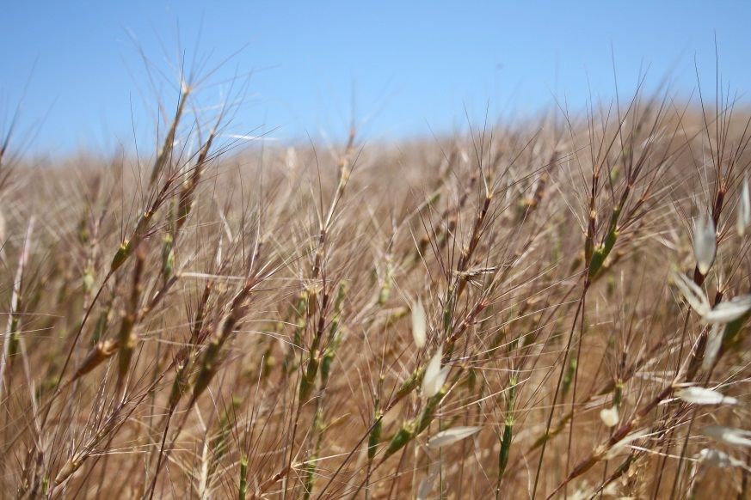

Goatgrass, *Aegilops truncialis*

Huge seeds with spiky “beards.” Entire seedhead falls off stem at senescence, leaving bare stem.

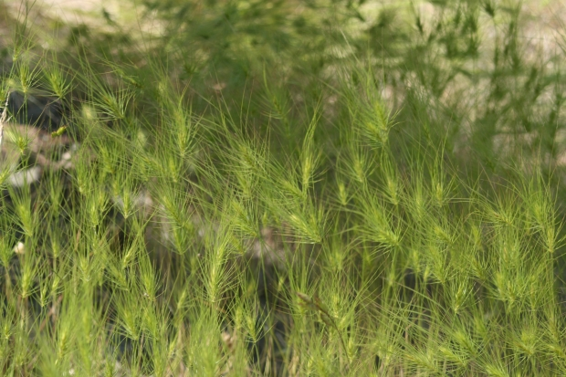 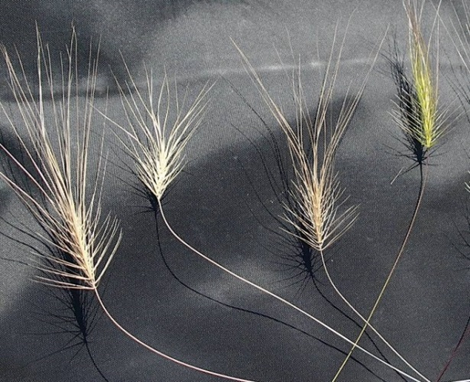

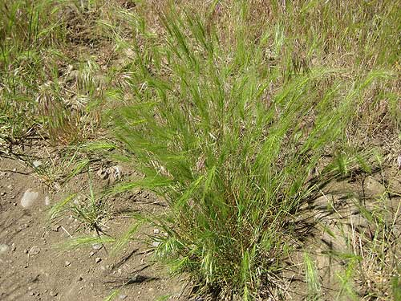

Medusahead, *Taeniatherum caput-medusae* (now *Elymus caput-medusae*)

Thin and wispy plant, seedheads look like brushes, tiny seeds with very long awns. Diminuitive plant until about May, then grows very quickly. Litter forms dense, impenetrable mat that suppresses other grasses.

**WEED EXCEPT IN “CESO” PLOTS**

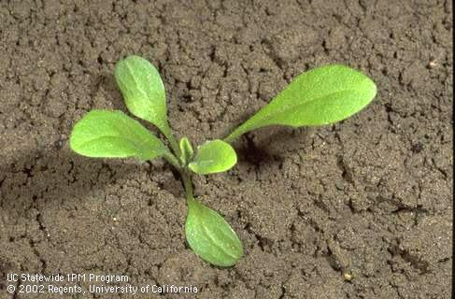 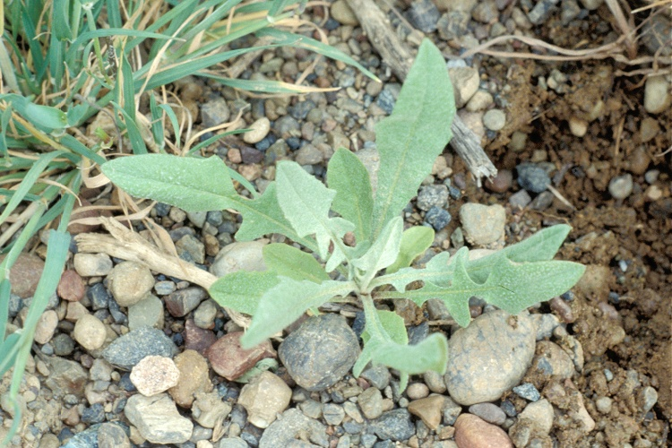

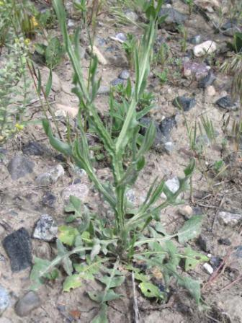 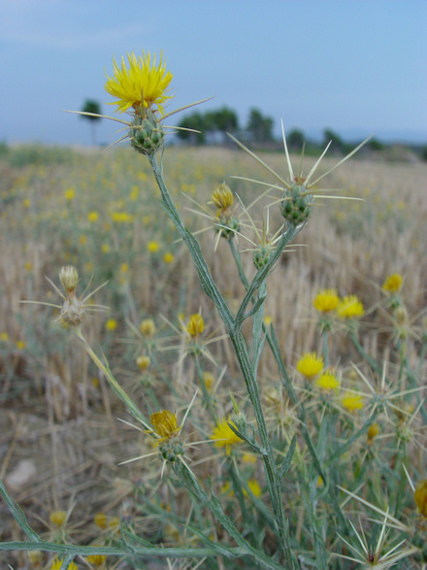

Yellow star thistle, *Centaurea solstitialis*

Colonizes bare ground. Rosette looks like dandelion. Deep taproots allow it can grow all summer, very prickly yellow flowers. Use the weeding tool and gloves when removing!

**COMMON WEEDS**

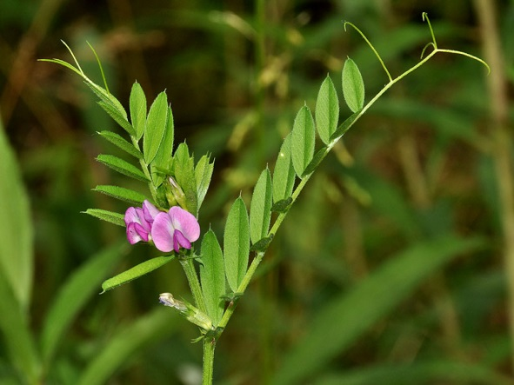 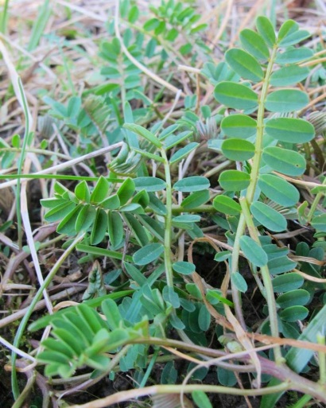

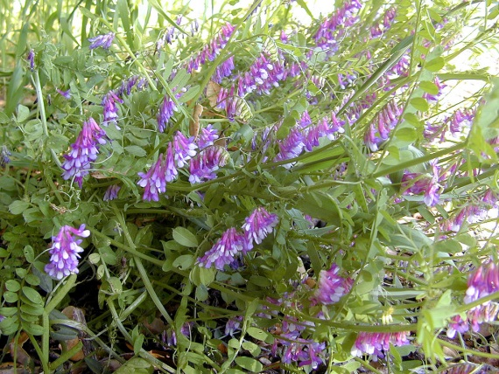 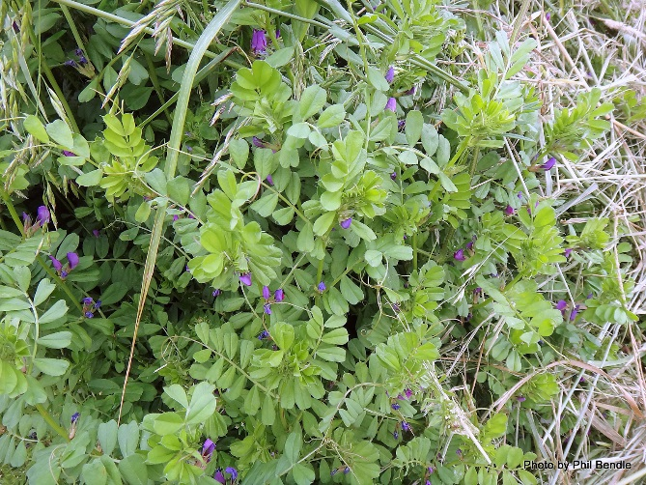

Vetches, *Vicia*

Leaflets arranged in rows, not triplet. Vine-like growth pattern and usually purple flowers. Be careful not to pull *Trifolium, Lupinus* or *Lotus* by mistake – as seedlings they look similar. This is the most abundant weed by far!

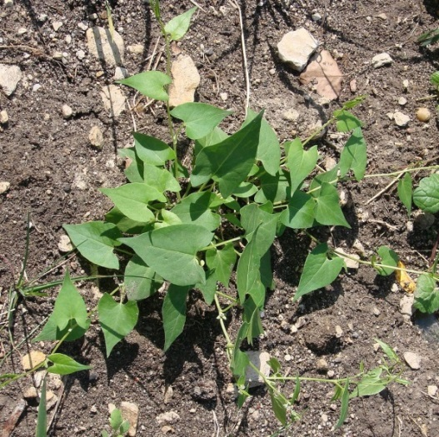 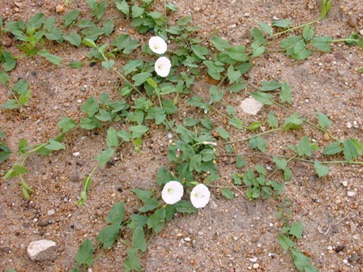

Bindweeds, Morning glory, etc.

Climb on other plants. Best to get them before they start climbing, trace them to the root and pull out the whole plant. High-priority weeding target

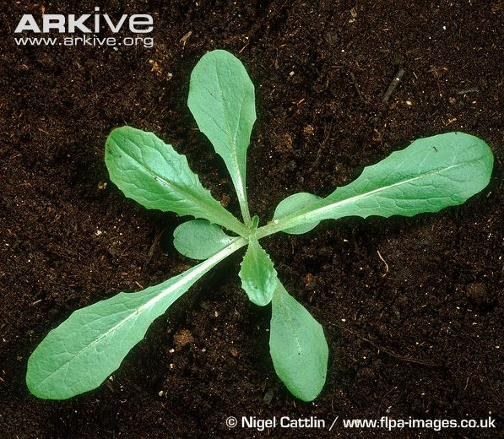 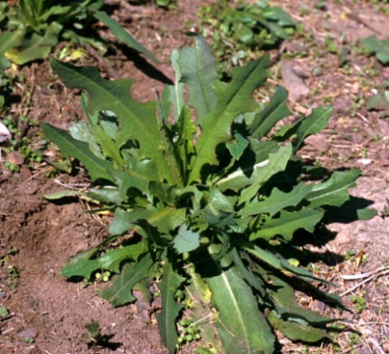

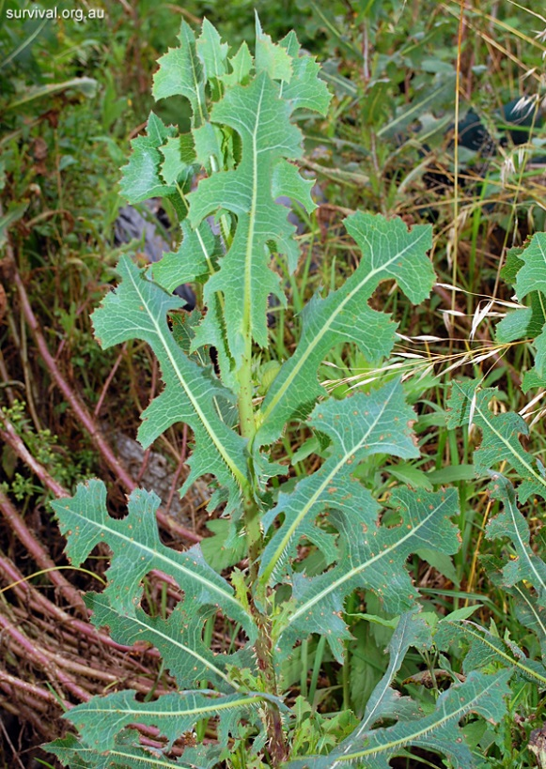 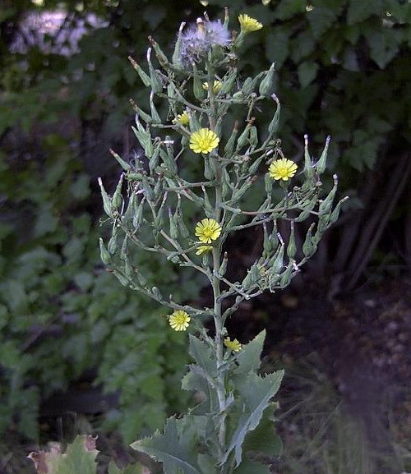

Wild lettuces, *Lactuca*

Look similar to dandelions or thistles when seedlings. Grows as rosette at first, bolts in the summer. They grow late into the summer. Use the weeding tool!

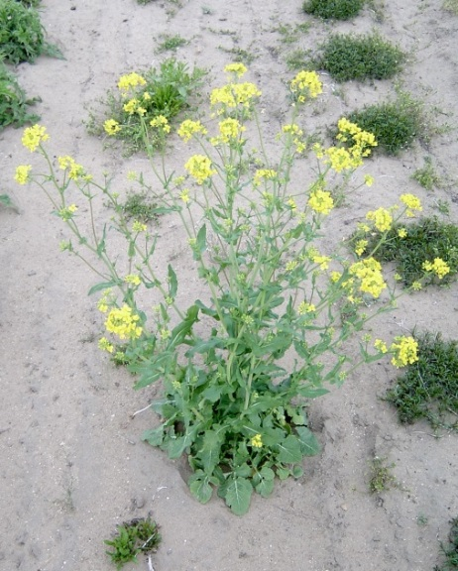 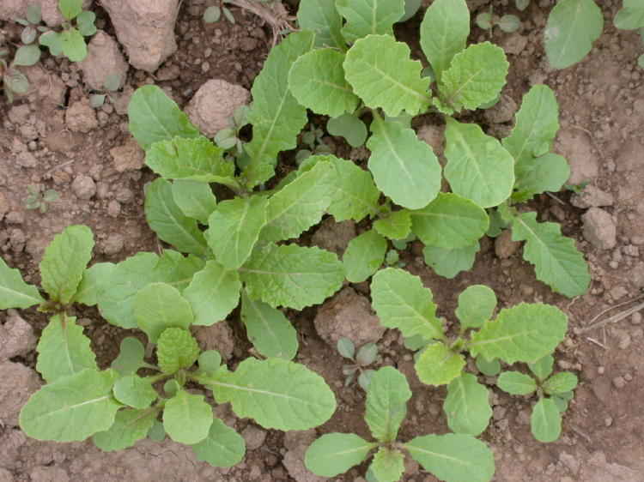

Mustards, radishes, *etc*., Brassica family

Come in all shapes and sizes.

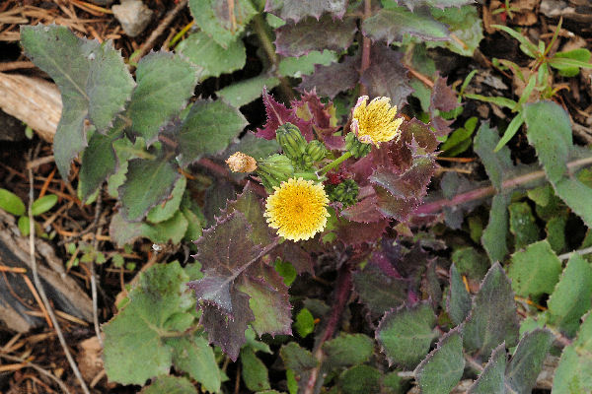 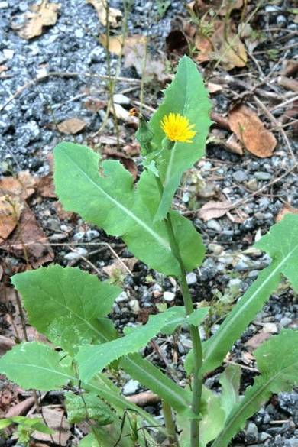

Sow thistles, *Sonchus*

Dandelion-like flower, but prickly leaves. Cannot pull out by hand, need to use the weeding tool.

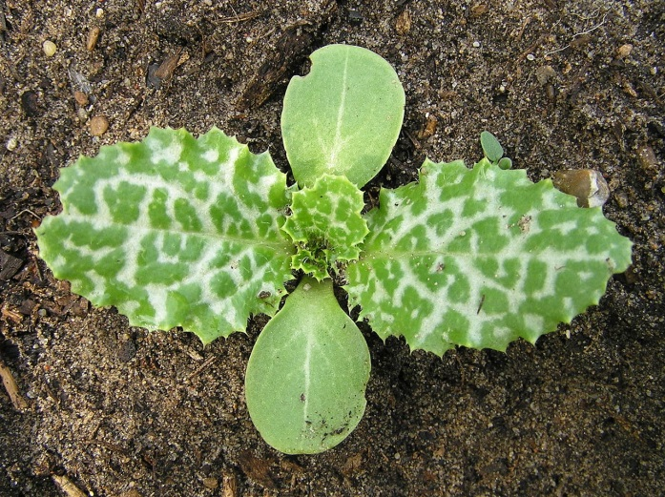 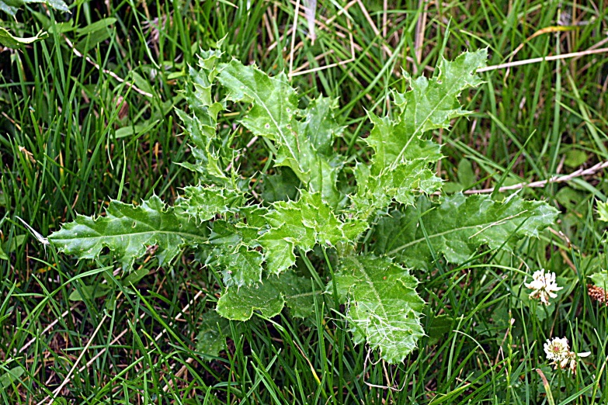

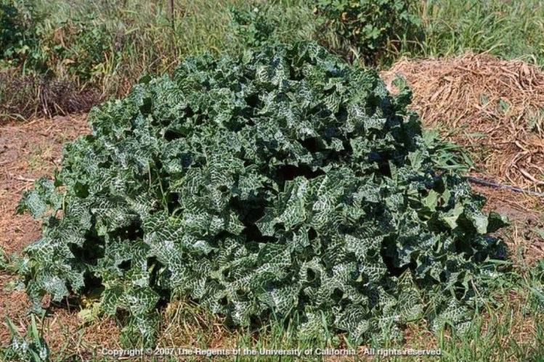 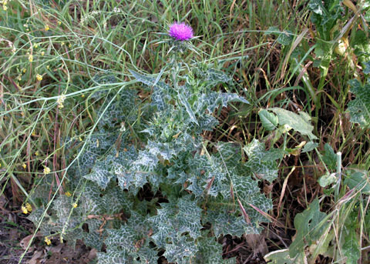

Thistles, especially Milk thistle (*Silybum marianum*)

Use gloves and the weeding tool!

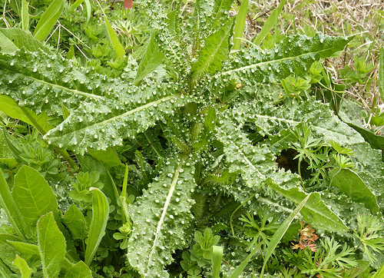 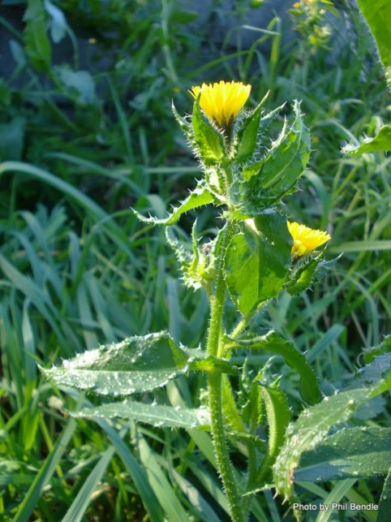

Bristly oxtongue, *Picris echioides*

OUCH! Warty-looking spines deliver a painful sting! Use gloves!!

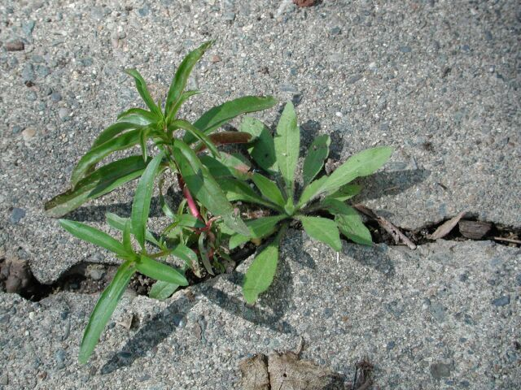 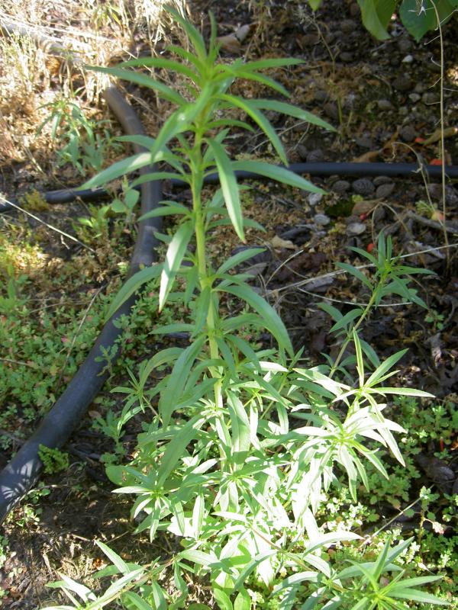 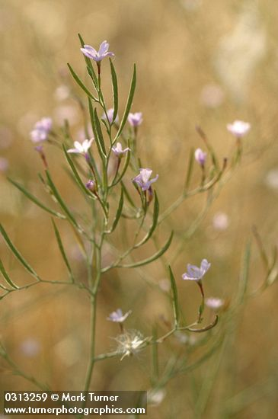

Willow weed or Fireweed, *Epilobium*

Native warm-season weed. Tiny seedling during spring, grows big over summer, purple flowers. Not worth worrying about until later in spring.

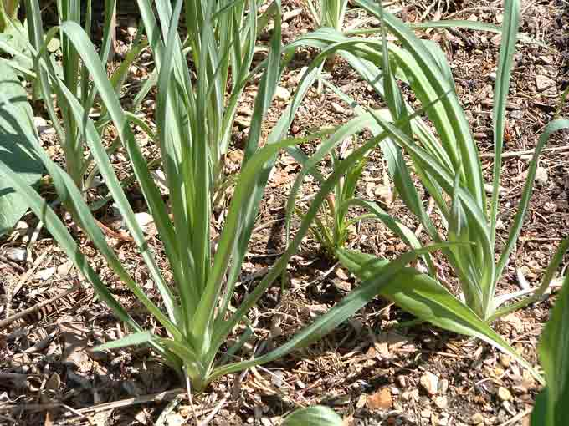 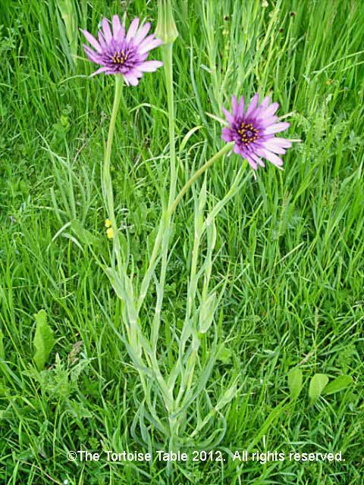

Salsify or Goatsbeard, *Tragopogon*

Looks deceptively like a grass, but actually a composite forb (family *Asteraceae* or *Compositae*). Usually not abundant, very difficult to pull – use the weeding tool.